1. State Space: $X=\left\{1,2,3,4\right\}×\left\{1,2,3,4\right\}$, that is, $X_{t}=\left(j_{t},k_{t}\right)∈{\left\{1,2,3,4\right\}}^{2}$, where $j_{t}$ is the current trailer position and $k_{t}$ is the current job position.

Control Space: $u_{t}$ is the next position of the trailer, $U=\left\{1,2,3,4\right\}$.

Transition kernel: $P\left[\left(j_{t+1},k_{t+1}\right)=\left(j,k\right)\left|j_{t},k_{t},u_{t}\right.\right]=\left\{\begin{aligned}p_{k_{t},k}, if j=u_{t}; \\ 0, otherwise.\end{aligned}\right.$

Step-wise cost:

$$c\left(j,k,u\right)=\left\{\begin{aligned}\begin{matrix}0, if k=1,u=j; \\ 200, if k>1,u=j=1;\end{matrix} \\ \begin{matrix}50, if k=u=j>1; \\ 100, if k>1,u=j∉\left\{1,k\right\};\end{matrix} \\ \begin{matrix}\begin{matrix}300, if k=1,u≠j; \\ 300+200, if k>1,u=1,j≠1;\end{matrix} \\ \begin{matrix}300+50, if k>1,u=k,j≠k; \\ 300+100, if k>1,u∉\left\{1,k\right\},j≠u;\end{matrix}\end{matrix}\end{aligned}\right.$$

The optimal value function $v^{*}:{\left\{1,2,3,4\right\}}^{2}→R$ satisfies the following dynamic programming equation

$v^{*}\left(j,k\right)=\min_{u∈\left\{1,2,3,4\right\}}\left\{c\left(j,k,u\right)+γ\sum_{l=1}^{4}{p_{k_{t},l}v^{*}(u,l)}\right\}$ for all $\left(j,k\right)∈X$.

1. Value iteration:

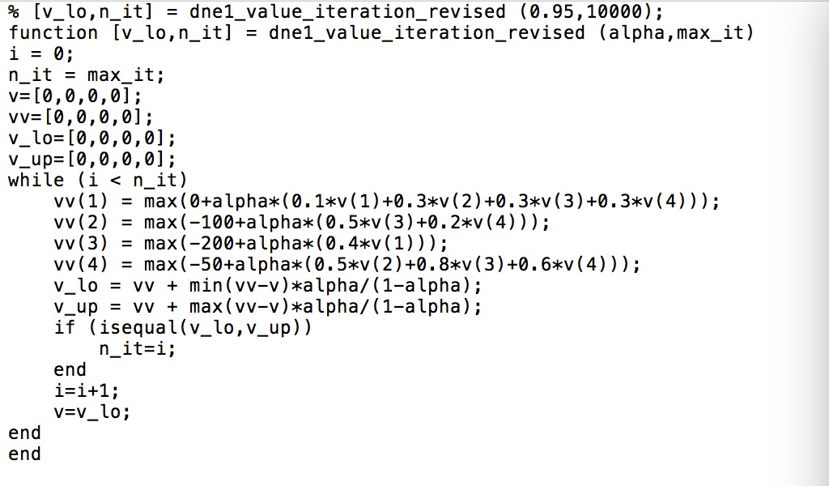

1. Policy iteration:





1. Linear programming:

